**David Ki**

**ENCE 3231**

**Embedded Systems Phase B**

**05/08/2023**

**Project Requirements:**

The project requirements for Phase B the kitchen timer are a speaker, reset, two buttons, four digits for the seven segment display, LEDs, battery power, and ability to connect to bluetooth. Below is a picture of my pcb board of the kitchen timer in a three dimensional viewer.

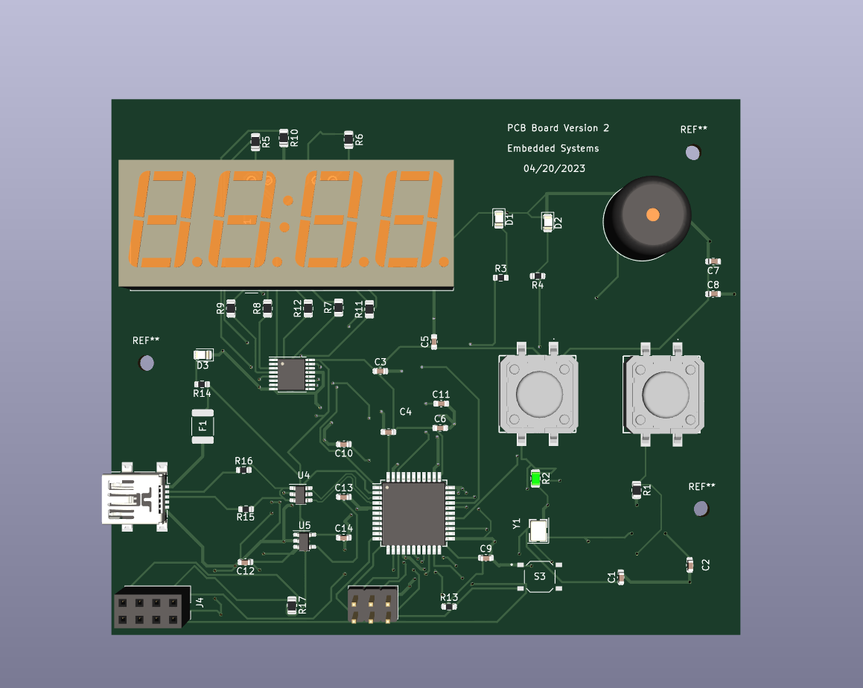

**System Design:**

The block diagram for the schematic of the kitchen timer is implemented below.

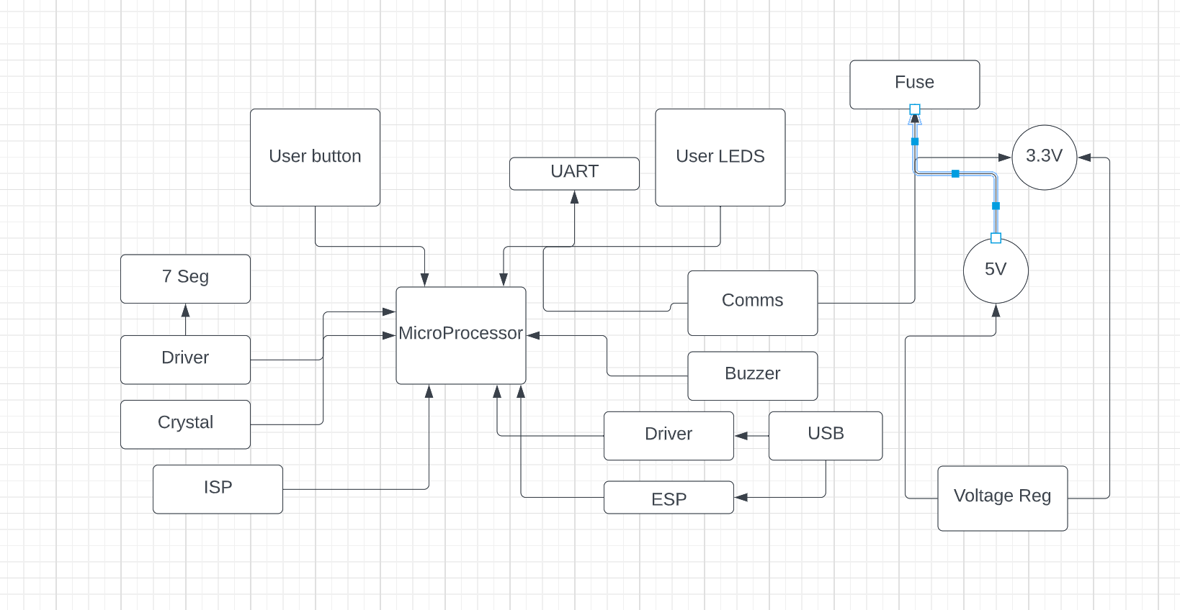

Figure 1: Block diagram of the kitchen timer layout

**Components Selection:**

The components selected for this kitchen timer are Arduino Uno board, 7-Segment display, SN74HC595 8-bit shift register, PTS125_SMD button, PTS526_SMD button, one red LED, one green LED, resistors, capacitors, mini speaker, and a ESP8266 for connecting to unique ip address.

**Build Prototype:**

Unlike phase A where we used an Arduino shield in phase B we are using the ATMEGA32U4 microprocessor that will act like the communicator like phase A to be able to accomplish the kitchen timer. This is the design in 3-D viewer of the kitchen timer for phase B. ‘

I have the usb sticking out for the purpose of plugging in a usb to the computer and for the design of my enclosure. The speaker is the same speaker from phase A and it is in the top right just for the asesthetics and it looks better that way and same reason why the seven segment display is put horizontal instead of vertical to be easier to read.



Figure 2: Design of my kitchen timer

**PCB Design:**

The design of my kitchen timer is shown in kicad as figure 2 above which was later used to create the layout for the PCB board. The schematic of my kitchen timer is shown below as figure 3 and the layout of my PCB layout is I have the USB slightly hanging off the board which would stick out the hole of the enclosure. The seven segment display is placed horizontally surrounded with a bunch of resistors. The microprocessor in the bottom slightly to the left. The layout is shown as figure 4 below.

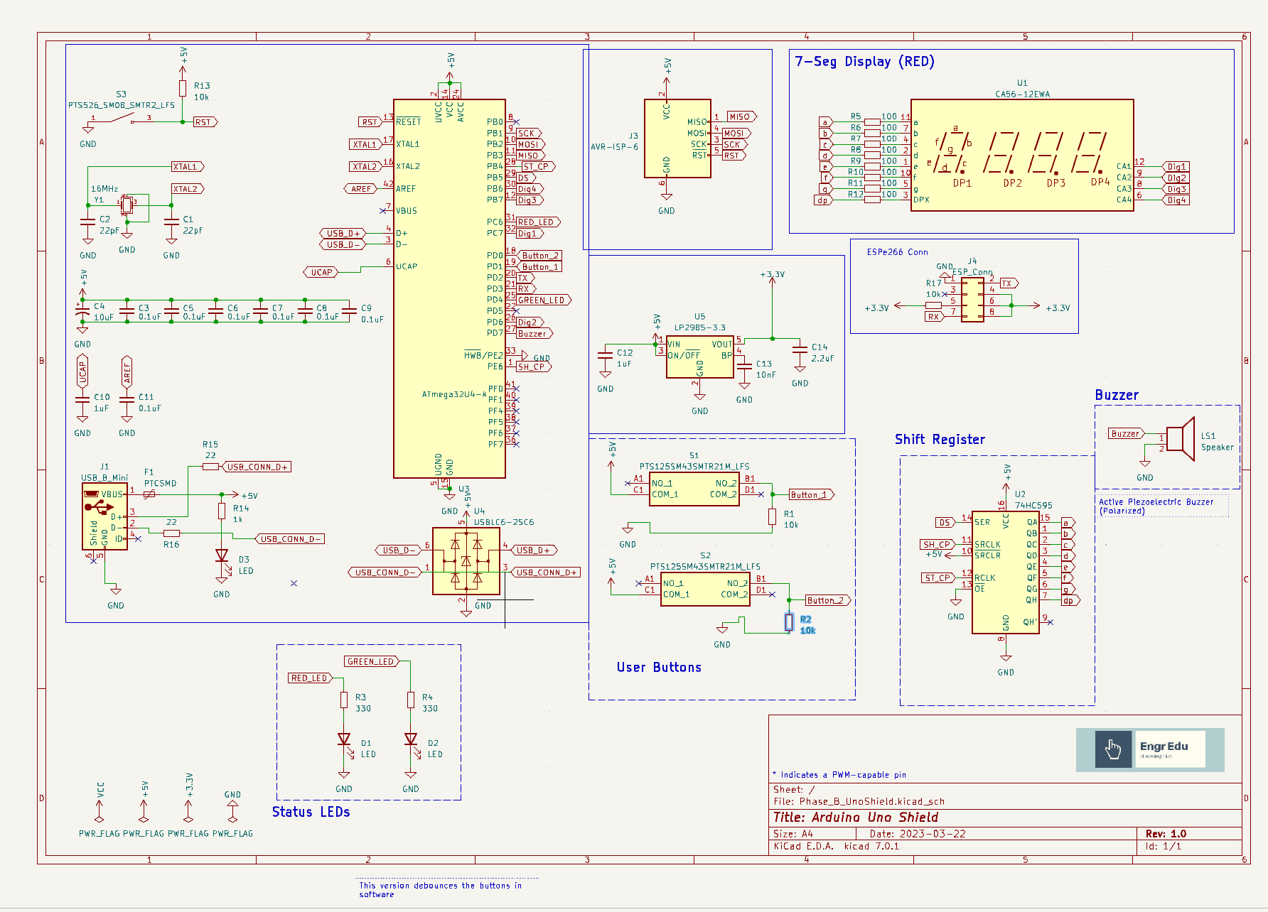

Figure 3: Schematic of kitchen timer

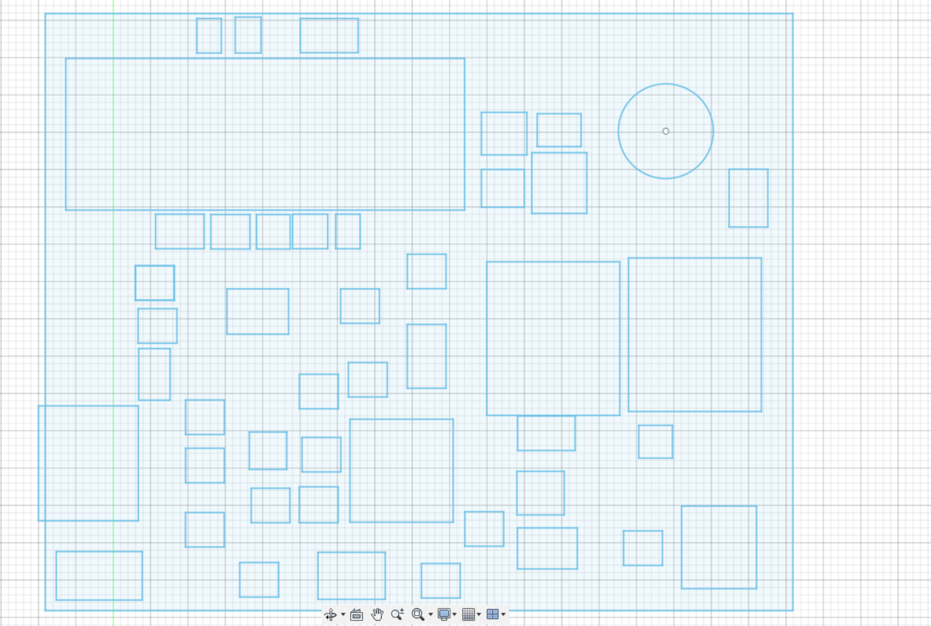

Figure 4: Design of my Kitchen Timer

**Assemble Stage:**

I have received my PCB board today in class so eventually I will solder the PCB board and then 3-D print my enclosure and then mount the PCB board in the enclosure and finish the code for the kitchen timer for phase B in the coming weeks.

**Software Development:**

There will be two block diagrams because we do need the code from phase A and a combination with the code written in phase B but to combine the code is not possible in Arduino because Arduino does not have a timer 4 as an interrupt flag. As shown below figure 5 is the block diagram for the code from phase A and figure 6 is the block diagram for the code from phase B.

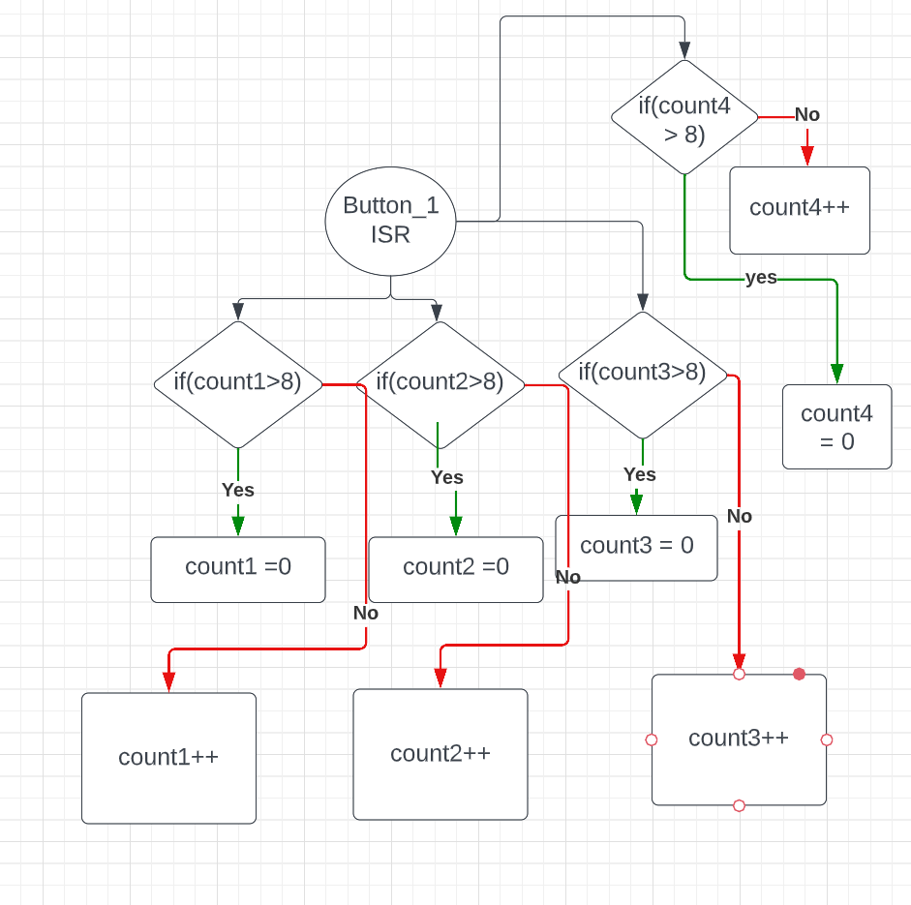

Figure 5: Button_1 ISR from code for Phase A

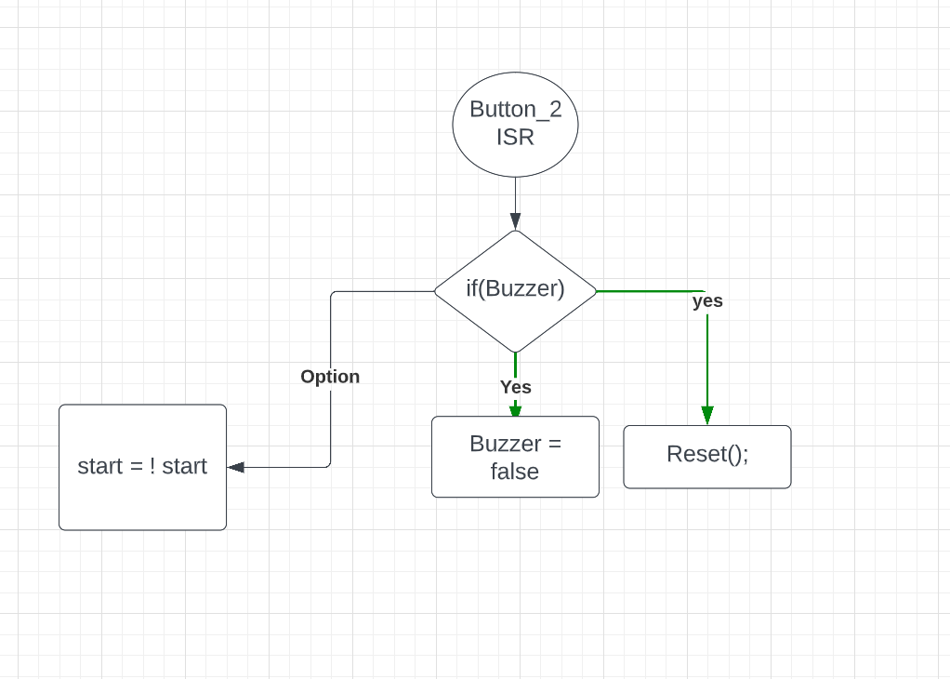

Figure 5: Button_2 ISR from phase A code

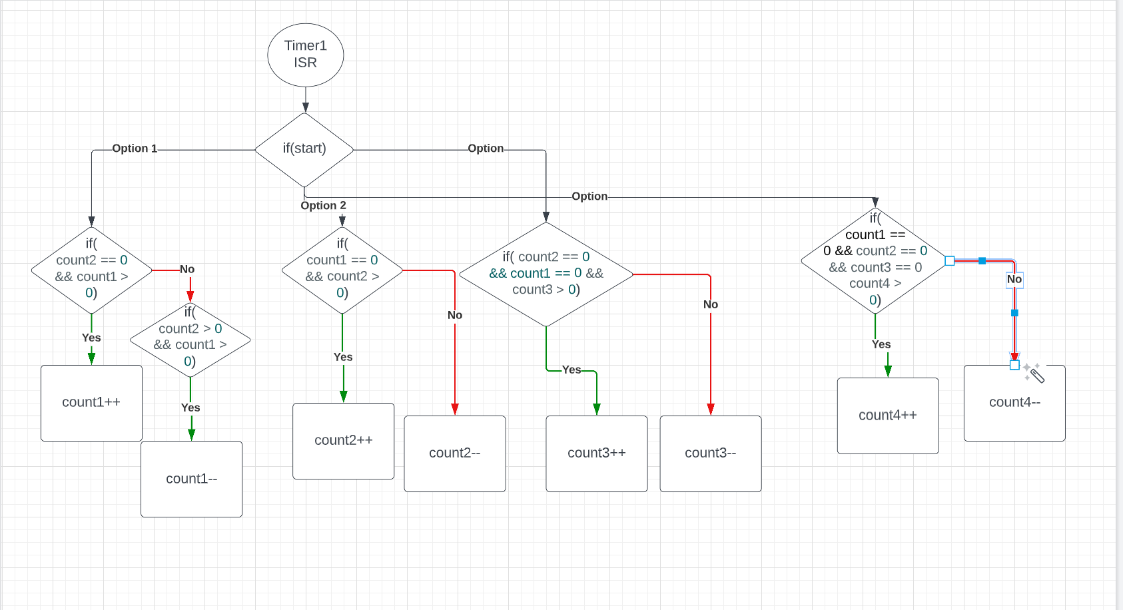

Figure 5: Timer1 ISR for code for phase A

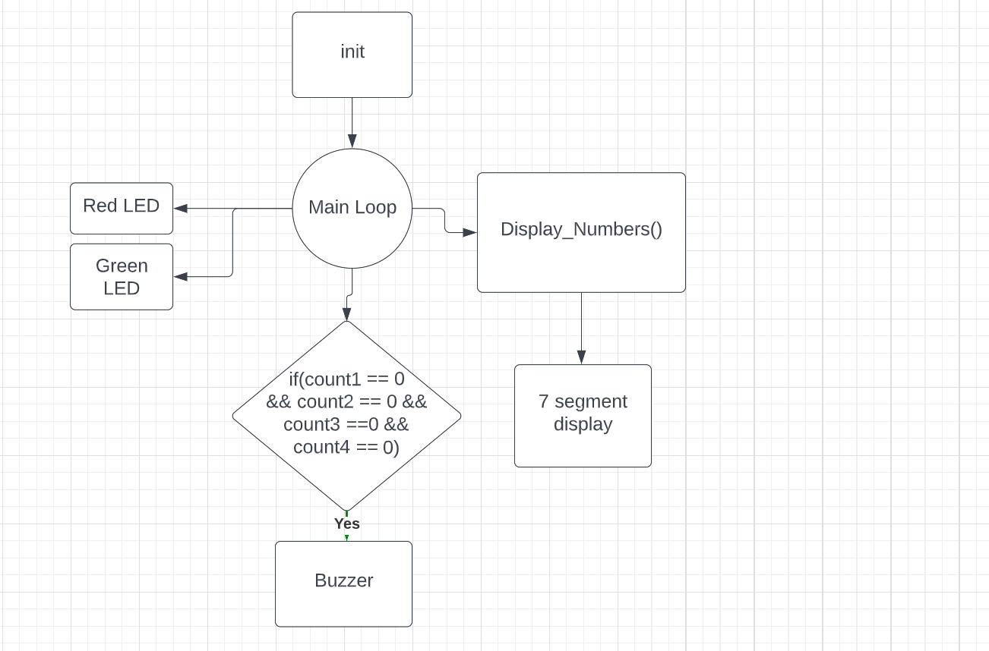

Figure 5: Main code for phase A

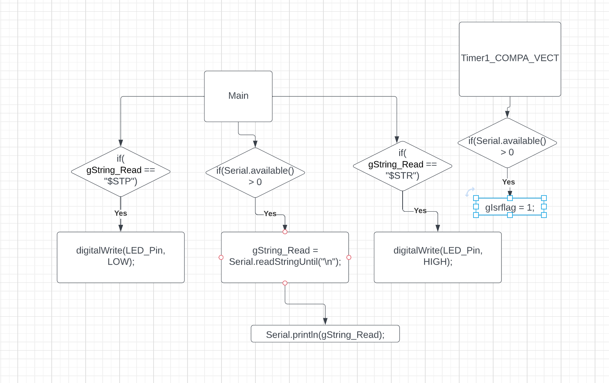

Figure 6: code for phase B

The code for phase B in Arudino is located in this Github link listed here:

[ENCE_3231_Class2023/Phase B/Arduino Code/ESP8266_Kitchen_Timer_Communication/ESP8266_Kitchen_Timer_Communication at main · Kkihamin/ENCE_3231_Class2023 (github.com)](https://github.com/Kkihamin/ENCE_3231_Class2023/tree/main/Phase%20B/Arduino%20Code/ESP8266_Kitchen_Timer_Communication/ESP8266_Kitchen_Timer_Communication)

**Enclosure Design:**

My enclosure design for my kitchen timer for phase B was designed in Fusion 360 which is a software that I have never used until I designed the enclosure for my kitchen timer. For my kitchen timer I only had one enclosure design which was for the bottom where my kitchen timer. Below is my design for my enclosure for my kitchen timer as figure 7.

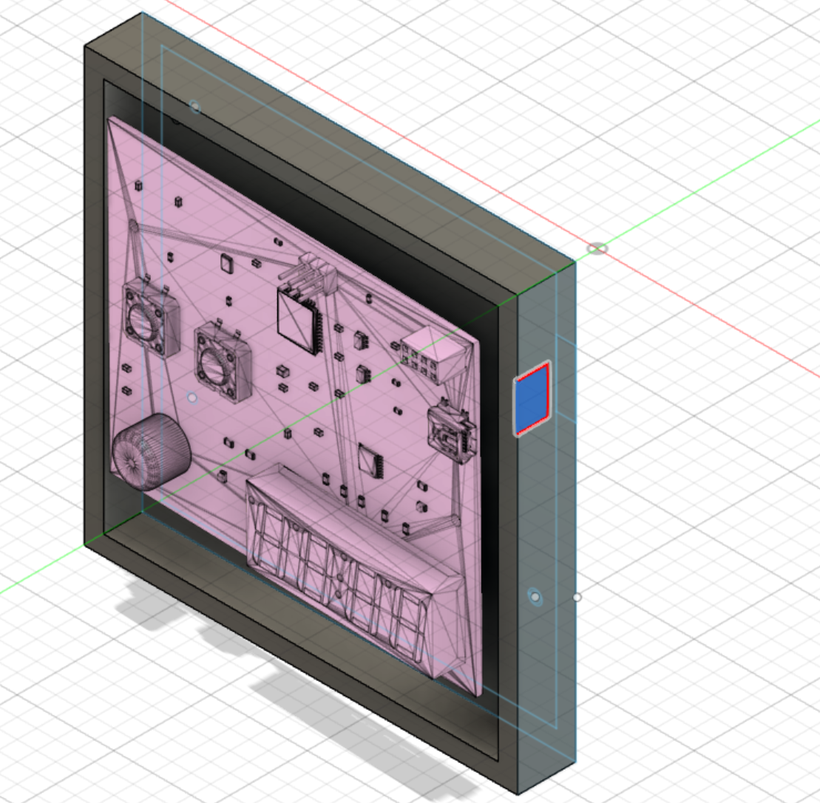

Figure 7: Enclosure Design for my Kitchen Timer

**Conclusion:**

The Kitchen Timer for phase B gave me the knowledge of getting to know more about Kicad and how to route and layout PCB so that if I wanted to make my own PCB on my own I would have the ability to make the PCB board. Also, phase B gave me an idea of how corporations in the real world would develop real world products and successfully manufacture these products in the real world. This phase B gave me valuable knowledge about PCB boards and might actually be very useful when I go into the workforce after graduating from school.